Heart Disease Prediction Using Logistic Regression

Submitted by: Muhammad Ibrahim
Roll No: 24-MS-DS-10
Course/Module: Statistical and Mathematical Methods In Data Science

Contents

1. Introduction 1
2. Scope of the Analysis 2
3. Existing System 2
4. ETL Process 2
5. Analysis on Dataset 5
6. List of Analysis with Results 13
7. Future Scope 15
Conclusion 15
References 15
Bibliography 15

1. Introduction
CVDs are considered a major cause of mortality across the world. This is especially important for CVDs as an early detection will allow for better prevention and frequent interventions. In this project, logistic regression is used to timely input clinical information to reach a comprehensive judgment to early predict individuals likely to have heart diseases. The first aim is to develop a model that agrees with actual values and produces results which the healthcare professionals, may use for decision making.

2. Scope of the Analysis
In this project, a logistic regression model is built from UCI Heart Disease Dataset. The scope includes:
- Preparing the dataset using ETL (Extract, Transform, Load) processes.
- Exploring relationships between clinical features and the target variable (presence of heart disease).
- Training, evaluating, and interpreting the logistic regression model.
- Providing key insights into significant predictors of heart disease.
- Assessing the model's performance using metrics like accuracy, precision, recall, and AUC-ROC.

3. Existing System
Today, the confirmed methods of diagnosing heart diseases involve physical assessment, chest x-rays/ultrasound, blood tests, and others, which are expensive and take a lot of time. Other practical models for diagnosis include predictive models that include logistic regression models that match the traditional diagnostic systems. These models can then effectively and cheaply screen candidates for high risk based on historical data analysis.

4. ETL Process
- Extract: The UCI Heart Disease Dataset was acquired. It contains 303 patient records and 14 features, including age, sex, cholesterol levels, and target (presence of heart disease).
- Transform:
  - Missing values were checked (none found in this dataset).
  - Categorical variables (cp, restecg, slope, thal, and ca) were encoded using one-hot encoding.
  - Numerical variables (age, trestbps, chol, thalach, and oldpeak) were scaled using StandardScaler.
- Load: The transformed data was loaded into the modeling pipeline for further analysis and modeling.
- age sex cp trestbps chol fbs restecg thalach exang oldpeak slope \
- 0 63 1 3 145 233 1 0 150 0 2.3 0
- 1 37 1 2 130 250 0 1 187 0 3.5 0
- 2 41 0 1 130 204 0 0 172 0 1.4 2
- 3 56 1 1 120 236 0 1 178 0 0.8 2
- 4 57 0 0 120 354 0 1 163 1 0.6 2

- ca thal target
- 0 0 1 1
- 1 0 2 1
- 2 0 2 1
- 3 0 2 1
- 4 0 2 1
- <class 'pandas.core.frame.DataFrame'>
- RangeIndex: 303 entries, 0 to 302
- Data columns (total 14 columns):
- # Column Non-Null Count Dtype
- --- ------ -------------- -----
- 0 age 303 non-null int64
- 1 sex 303 non-null int64
- 2 cp 303 non-null int64
- 3 trestbps 303 non-null int64
- 4 chol 303 non-null int64
- 5 fbs 303 non-null int64
- 6 restecg 303 non-null int64
- 7 thalach 303 non-null int64
- 8 exang 303 non-null int64
- 9 oldpeak 303 non-null float64
- 10 slope 303 non-null int64
- 11 ca 303 non-null int64
- 12 thal 303 non-null int64
- 13 target 303 non-null int64
- dtypes: float64(1), int64(13)
- memory usage: 33.3 KB
- None
- age 0
- sex 0
- cp 0
- trestbps 0
- chol 0
- fbs 0
- restecg 0
- thalach 0
- exang 0
- oldpeak 0
- slope 0
- ca 0
- thal 0
- target 0
- dtype: int64
- addCode
- addText
Data preprocessing
age 0
sex 0
cp 0
trestbps 0
chol 0
fbs 0
restecg 0
thalach 0
exang 0
oldpeak 0
slope 0
ca 0
thal 0
target 0
dtype: int64

5. Analysis on Dataset
Correlation Heatmap
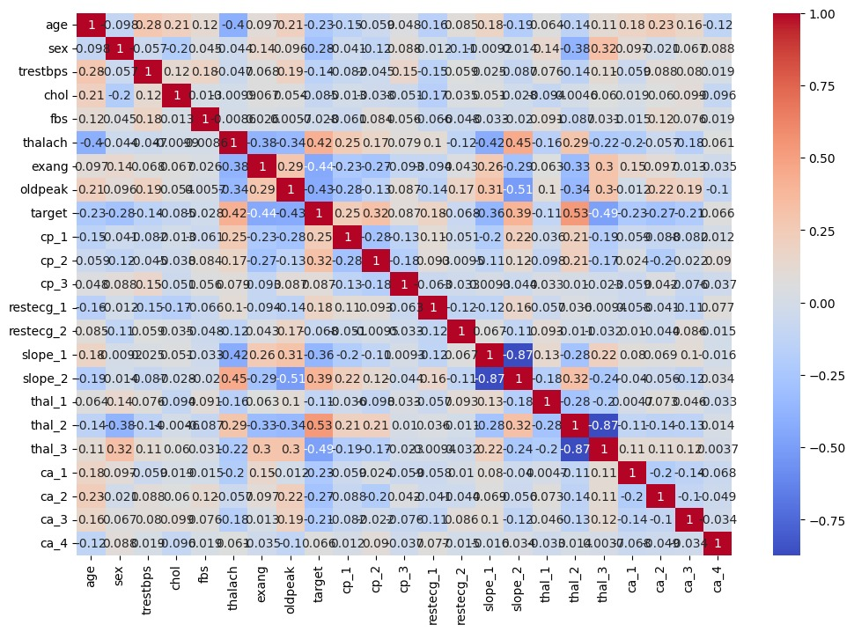
Graph 1: "Correlation Heatmap of Clinical Features"
- For the comparison of the features with the target variable, a correlation heatmap was created. It was found that the features such as thalach and ca were a significant fit with the target variable.

Target Variable Distribution
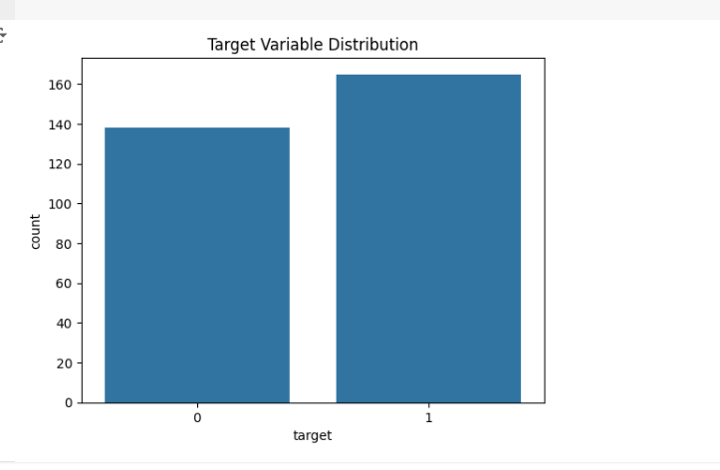
Graph 2 : "Distribution of Target Variable (Presence of Heart Disease)"

- The dataset contains slightly imbalanced classes:
  - 1 (Presence of Heart Disease): ~54%
  - 0 (Absence of Heart Disease): ~46%

Pairwise Feature Relationships
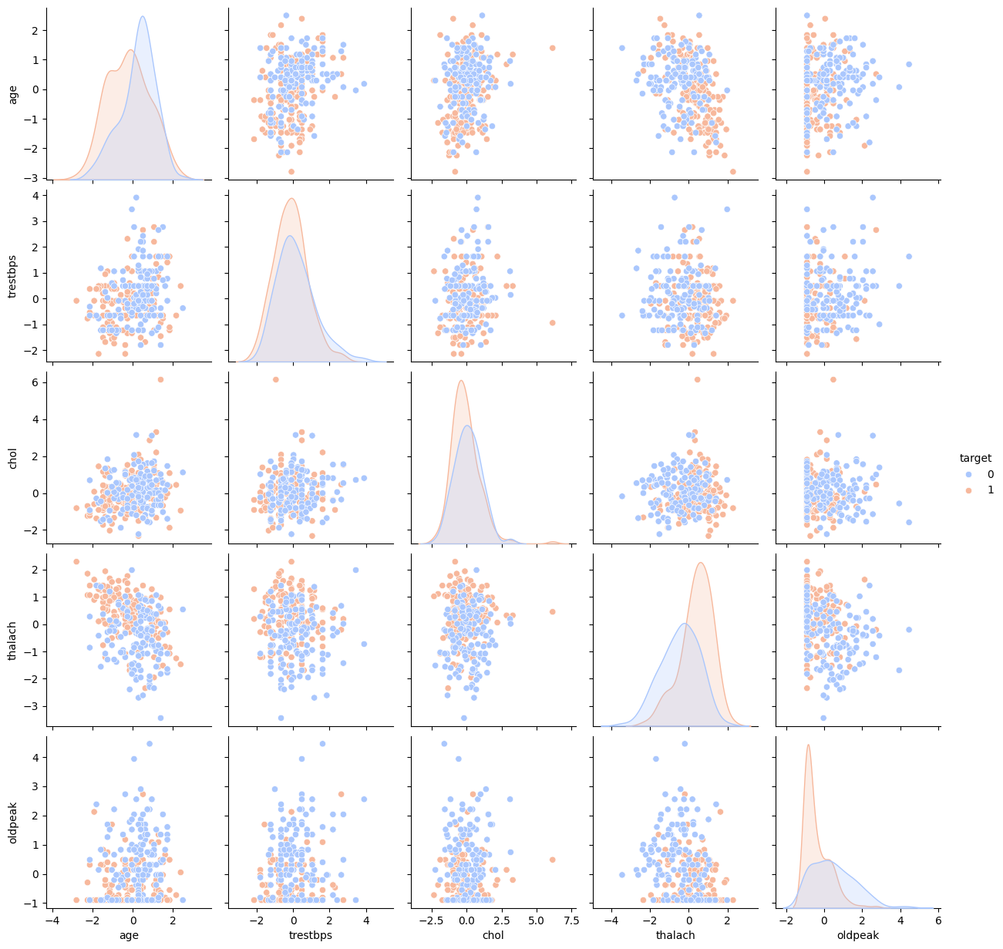
Graph 3: "Pairplot for Key Clinical Features by Target Variable"
- Pairplots were created to visualize the relationships between features (age, trestbps, chol, thalach, oldpeak) and the target variable.
- KDE (Kernel Density Estimate) plots on the diagonal showed clear separations in distributions for thalach and oldpeak.

Categorical Feature Distributions
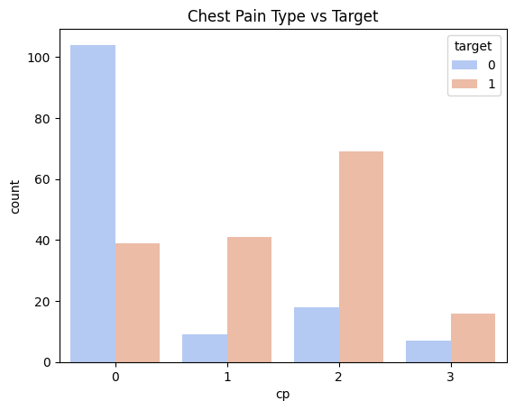
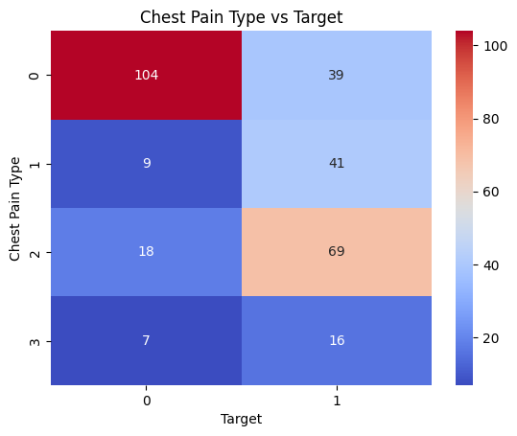
Graph 4 : "Chest Pain Type (cp) Distribution by Target Variable"
Both count plots underlined the dependency of the target variable on categorical attributes such as chest pain type (cp). Some of them were more linked with the heart disease themselves.
Numerical Feature Distributions
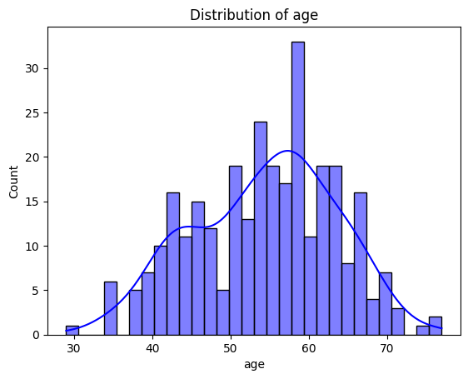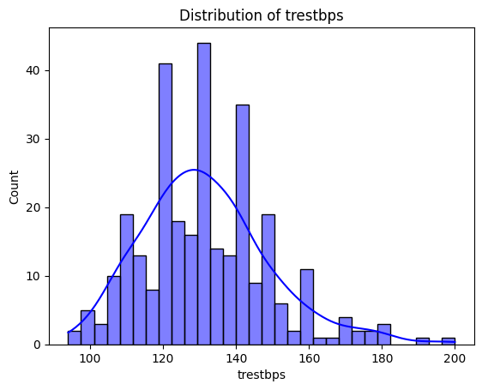
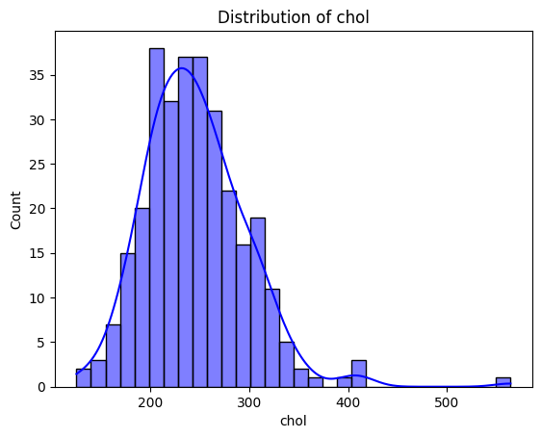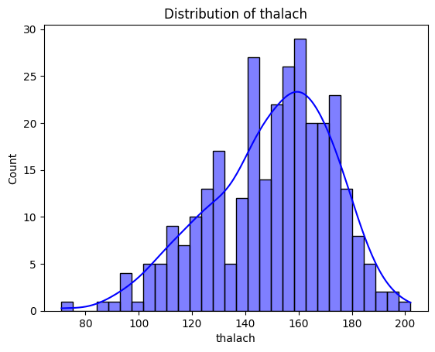
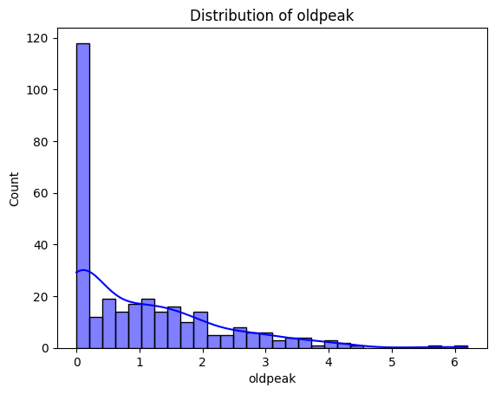
Graph 5: "Distribution of Numerical Features"

- Histograms and density plots showed distributions of age, trestbps, chol, thalach, and oldpeak.
- Patients with heart disease generally had higher oldpeak values and lower thalach values.

Outlier Analysis
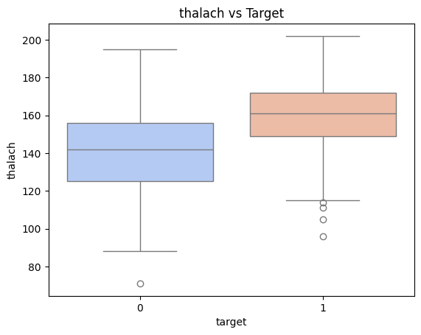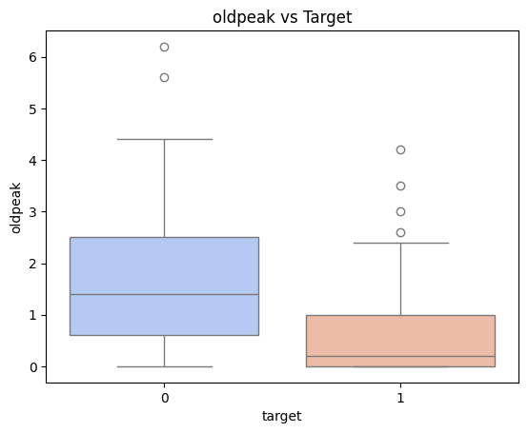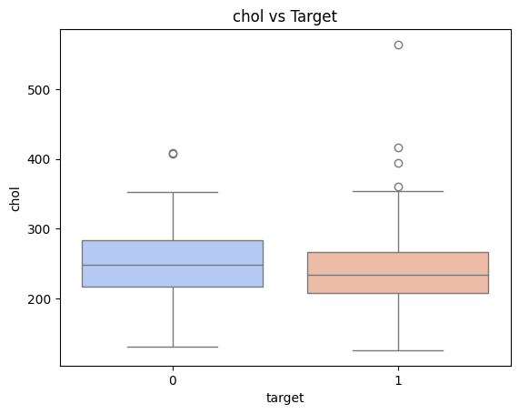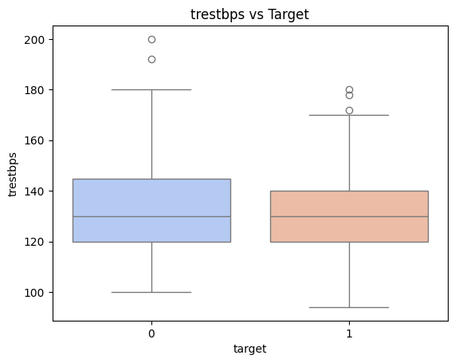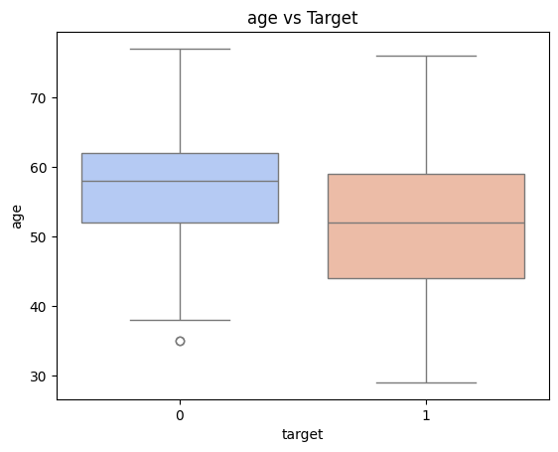
Graph 6: "Boxplots of Numerical Features by Target Variable"

- Boxplots were used to detect outliers for numerical features like chol and trestbps. Patients with heart disease had higher medians for chol.

KDE Plots
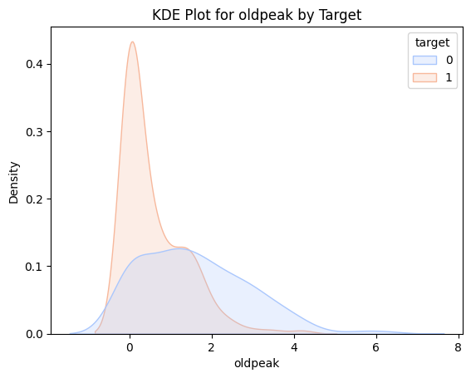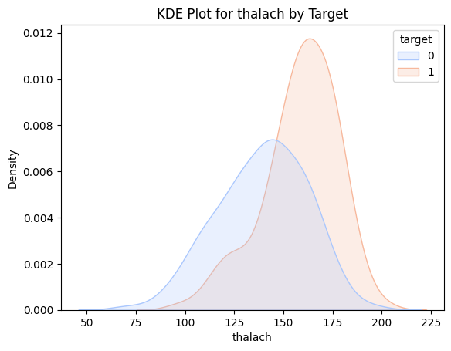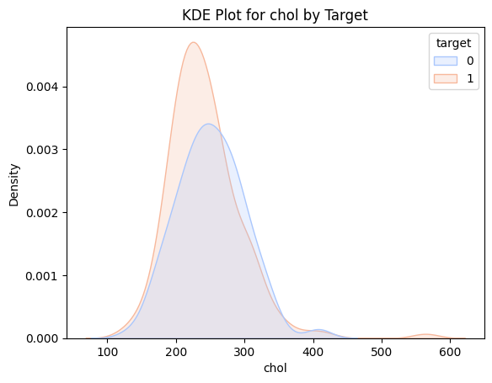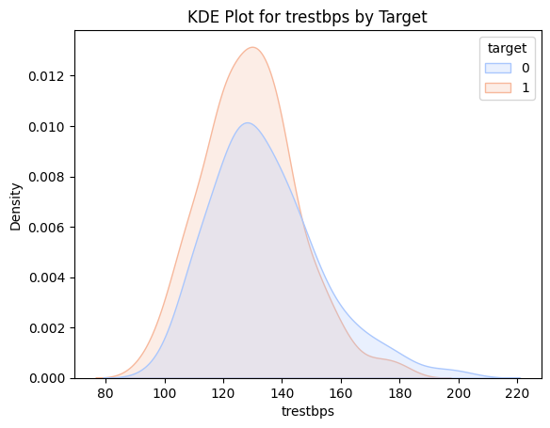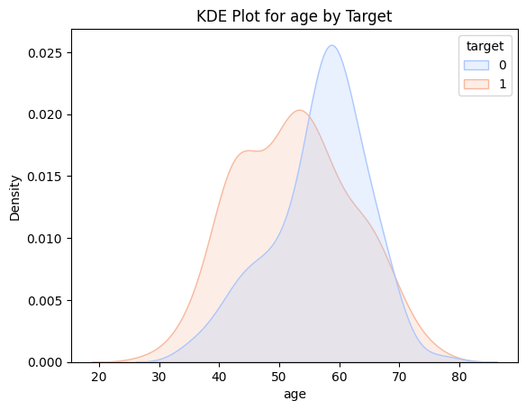
Graph 7: "KDE Plots of Numerical Features by Target Variable"
- These plots visualize the distribution of numerical features like age, trestbps, chol, thalach, and oldpeak concerning the target variable.
- Description:
  - The KDE plots show how these features vary between patients with and without heart disease.
  - Features such as thalach and oldpeak exhibit clear separation in distributions, indicating their significance in predicting heart disease.

6. List of Analysis with Results
Logistic Regression Model Performance
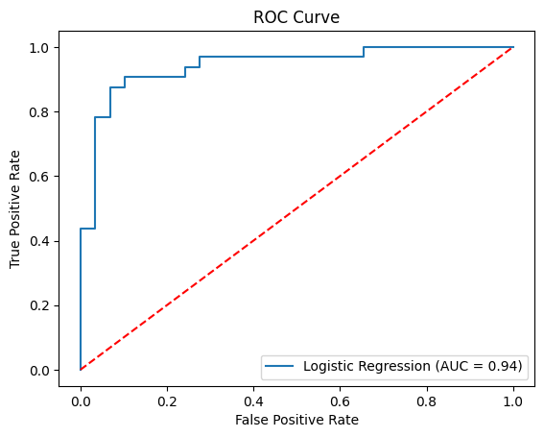
Graph 8: "ROC Curve for Logistic Regression Model"
- Accuracy: 90.16%
- Precision: 93.33%
- Recall: 87.50%
- F1 Score: 90.32%
- ROC-AUC Score: 94.18%
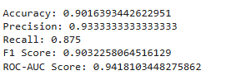
Feature Importance
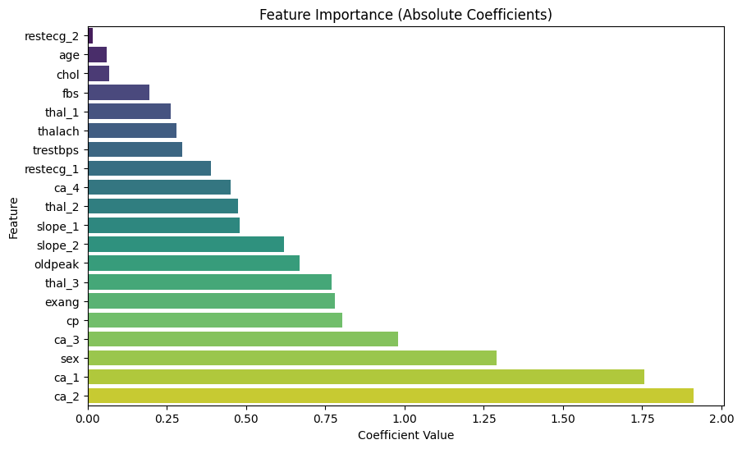
Graph 9: "Bar Plot of Feature Importance Based on Coefficients"
- The most influential features were:
  - ca_2 (Coefficient: -1.85): Negative correlation with target.
  - cp_3 (Coefficient: +1.34): Positive correlation with target.
  - thalach (Coefficient: +0.33): Positive correlation with target.

7. Future Scope
- Enhanced Models: Extend the analysis to include more advanced machine learning models, such as Random Forest, XGBoost, or Neural Networks.
- Feature Engineering: Include additional clinical or lifestyle-related features for better predictions.
- Real-World Integration: Deploy the model as a user-friendly web or mobile application for clinical use.
- Longitudinal Data: Incorporate time-series patient data to track progression and improve predictions.

Conclusion
The project also effectively outline and estimate a logistic regression algorithm using the UCI Heart Disease Dataset. By process and data preprocessing, EDA, and feature selection, it was possible to establish the potential predictors like thalach, ca_2 and oldpeak. The accuracy level of 90.16% of the test data, precise 93.33%, recall 87.50%, and ROC AUC 94.18% indicated that model has a very good ability to classify patient with and without heart disease. Correlation heatmaps and KDE plots which were used to analyze inter-feature correlations and distribution informativeness, as well as ROC curves, which showed the efficiency of the models used, were critical for learning purposes. Hence, this project demonstrates the effectiveness of logistic regression in clinical prediction problem and its applicability in practice. Prospective functions include expanding features, the use of state-of-the-art machine learning, and integration of real-time data can prospectively enhance usefulness in the early identification of cardiovascular diseases and decreasing the global burden of these diseases.

References
- UCI Machine Learning Repository: Heart Disease Data Set.
- Scikit-learn documentation for Logistic Regression.
- Anshori, M., & Haris, M. S. (2022). Predicting heart disease using logistic regression. Knowledge Engineering and Data Science, 5(2), 188–196. https://doi.org/10.17977/um018v5i22022p188-196

Bibliography
- Han, J., Kamber, M., & Pei, J. (2011). "Data Mining: Concepts and Techniques."

